Table of Contents
- Features
- Quick Start
  - Prerequisites
  - Installation
- Project Structure Example
- Commands
  - Configure Workspace
  - Update Project Version
  - Create New Environment
  - Create Requirements.txt
  - Export Environment.yml
- Workflow Example
- Shell Auto-Activation
- Generated Workspace Structure
- Project Type Configurations
- Environment Detection
- Integration with Existing Scripts
- Logging & Output
- UI: Explorer + Activity Bar
- Activation Notes
- Requirements
- Troubleshooting
- Platform-Specific Notes
- Manual Configuration
- License
- Contributing
- Support

Features
- One-Click Workspace Configuration: Automatically configure VS Code workspace with conda environment integration
- Environment Selection: Choose from any available conda environment
- Multi-Platform Support: Works on Windows (PowerShell), macOS (zsh/bash), and Linux (bash)
- Shell Auto-Activation: Automatically activates conda environment when entering project directory
- Multi-Project Support: Works with Python, Node.js, and mixed projects
- Version Management: Integrated project version updates with changelog generation
- Zero Configuration: Works out of the box with existing conda setups

Quick Start

Prerequisites
- VS Code 1.70.0 or higher
- Conda (Miniconda/Anaconda) installed and configured
- At least one conda environment available
- Node.js 16.0.0 or higher (for version management)

Installation
- Install the extension:
code --install-extension smart-conda-workspace-1.0.1.vsix

- Open your project in VS Code
- Configure workspace: Ctrl+Shift+P → "Smart Conda: Configure Workspace"
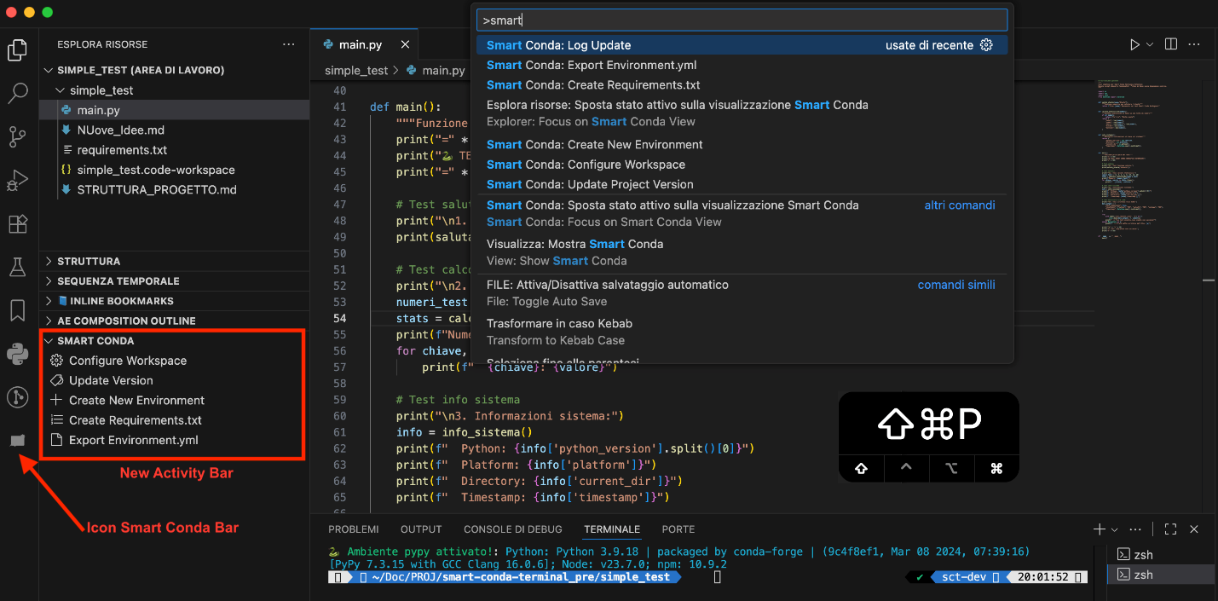

Project Structure Example

Minimal Python Project Structure
For the extension to work optimally, your Python project should have this basic structure:
my-python-project/
├── scripts/
│ └── update-version.js # Required for version management
├── package.json # Required for version tracking
├── pyproject.toml # Alternative to package.json
├── environment.yml # Conda environment definition
├── src/
│ └── my_package/
│ ├── __init__.py
│ └── main.py
├── tests/
│ └── test_main.py
├── README.md
└── .gitignore

Key files for extension functionality:
- scripts/update-version.js - Version management script
- package.json - Version tracking and project metadata
- environment.yml - Conda environment specification (optional)

Commands

Configure Workspace
- Command: Smart Conda: Configure Workspace
- Shortcut: Ctrl+Shift+P → type "configure workspace"
- Description: Creates optimized VS Code workspace configuration with shell auto-activation
What it does:
- Scans available conda environments
- Lets you select the environment for your project
- Detects project type (Python/Node.js/Mixed)
- Generates .code-workspace file with optimized settings
- Configures shell auto-activation
- Creates backup of shell configuration

Update Project Version
- Command: Smart Conda: Update Project Version
- Shortcut: Ctrl+Shift+P → type "update version"
- Description: Manages project versioning using existing scripts
Requirements:
- scripts/update-version.js must exist in your project
- package.json or pyproject.toml with version field
What it does:
- Reads current version from project files
- Shows version increment options (patch/minor/major)
- Executes your project's scripts/update-version.js
- Updates version files and generates changelog

Create New Environment
- Command: Smart Conda: Create New Environment
- Description: Creates a new Conda environment from a template or from environment.yml
What it does:
- Prompts for environment name (or uses default from template)
- Creates the environment with conda env create or conda create
- Optionally writes/updates environment.yml

Create Requirements.txt
- Command: Smart Conda: Create Requirements.txt
- Description: Generates requirements.txt from the active environment or from environment.yml
What it does:
- Reads packages from the active Conda environment
- Normalizes versions and outputs a clean requirements.txt
- Supports fallback to environment.yml when environment is not active

Export Environment.yml
- Command: Smart Conda: Export Environment.yml
- Description: Exports the environment definition to environment.yml
What it does:
- Uses conda env export --from-history when available
- Cleans metadata for portability
- Saves environment.yml in the project root

Workflow Example
# 1. Open your project
cd /path/to/your/project
code .
# 2. Configure workspace (Ctrl+Shift+P)
Smart Conda: Configure Workspace
├── Select conda environment: "my-env"
├── Select project type: "Python"
├── ✅ Workspace file created
└── ✅ Shell auto-activation configured
# 3. Close and reopen from workspace file
# Environment now auto-activates when entering project directory
# 4. Update version when needed (Ctrl+Shift+P)
Smart Conda: Update Project Version
├── Current: 1.0.0
├── Select: "minor" → 1.1.0
└── ✅ Version updated + changelog

Shell Auto-Activation
The extension automatically configures your shell to activate the conda environment when you enter the project directory.

Supported Platforms
Platform | Shell | Configuration File
Windows | PowerShell | ~/Documents/PowerShell/Microsoft.PowerShell_profile.ps1
macOS | zsh | ~/.zshrc
macOS | bash | ~/.bash_profile or ~/.bashrc
Linux | bash | ~/.bashrc

Example Configuration Added
For Unix systems (macOS/Linux):
# *my-project* - Auto-activation
# Generated by Smart Conda Workspace on [timestamp]
my_project() {
if [[ "$PWD" == *"/path/to/my-project"* ]]; then
conda activate my-env 2>/dev/null || true
fi
}
# ZSH integration
if [[ -n "$ZSH_VERSION" ]]; then
chpwd_functions+=(my_project)
my_project # Activate now
fi

For Windows PowerShell:
# *my-project* - Auto-activation
function my_project {
$currentPath = Get-Location
if ($currentPath.Path -like "*C:\path\to\my-project*") {
conda activate my-env
}
}
# Auto-trigger on directory change

Terminal Activation Message
After environment activation, the terminal displays a unified single-line status message across platforms:
🐍 Ambiente <env> attivato! : Python: <version>; Node: <version>; npm: <version>

Platform-specific behavior:
- Python is always displayed; Node and npm only appear if available in the active environment
- macOS/Linux use ANSI colors (green for environment name; cyan for versions)
- Windows PowerShell displays colors, while CMD uses a fallback without colors
- Verbose conda activate output is suppressed on macOS/Linux to avoid duplicate messages while keeping the summary line

Generated Workspace Structure
After running "Configure Workspace", you'll get:
your-project.code-workspace
{
"folders": [{ "path": "." }],
"settings": {
"python.defaultInterpreterPath": "/path/to/conda/envs/your-env/bin/python",
"python.condaPath": "/path/to/conda/bin/conda",
"python.terminal.activateEnvironment": true,
"terminal.integrated.defaultProfile.osx": "conda-env"
},
"extensions": {
"recommendations": [
"ms-python.python",
"ms-python.vscode-pylance"
]
}
}

Project Type Configurations

Python Projects
- Settings: Black formatter, Pylint, pytest integration
- Extensions: Python, Pylance, Black formatter, Jupyter
- Terminal: Auto-activates conda environment

Node.js Projects
- Settings: Prettier, TypeScript support, auto-imports
- Extensions: Prettier, TypeScript, Tailwind CSS
- Terminal: Node.js + conda environment

Mixed Projects
- Settings: Combined Python + Node.js configuration
- Extensions: Both Python and Node.js development tools
- Terminal: Full stack development ready

Environment Detection
The extension automatically detects:
- Available conda environments via conda env list
- Current active environment (shown first in selection)
- Python versions for each environment
- Project type based on files (package.json, pyproject.toml, etc.)
- Platform-specific paths (Windows vs Unix)

Integration with Existing Scripts
This extension integrates with project scripts:
- scripts/update-version.js: Called for version management
- package.json: Read for current version and metadata
- pyproject.toml: Alternative version source for Python projects
- environment.yml: Conda environment configuration
Note: The update-version.js script must exist in each project where you want version management, not in the extension itself.

Logging & Output
- The extension writes human-readable logs to the Output channel Smart Conda Logs
- Open via View → Output and pick Smart Conda Logs from the dropdown
- Typical entries include environment detection, command registration, and update events

UI: Explorer + Activity Bar
- The "Smart Conda" view in Explorer is always visible when at least one workspace folder is open (workspaceFolderCount > 0)
- The Activity Bar icon provides quick access without affecting Explorer section visibility
- Removed "Show/Hide in Explorer" button from TreeView and smartConda:explorerVisible logic
- TreeView exposes 5 operational actions: Configure Workspace, Update Version, Create New Environment, Create Requirements.txt, Export Environment.yml
- Updated manifest (vscode-extension/package.json): Explorer view when condition set to workspaceFolderCount > 0

Activation Notes (projects without environment.yml)
- The extension activates on startup and when a workspace folder is present
- environment.yml is optional: if absent, you can still run Smart Conda: Configure Workspace and select a conda environment manually
- Environment name inference in some features prefers environment.yml if present; otherwise falls back to heuristic detection or prompts

Requirements

For Workspace Configuration
- Any conda environment available
- Write permissions in project directory
- Shell configuration file write permissions

For Version Updates
- scripts/update-version.js script in your project
- package.json or pyproject.toml with version field
- Git repository (optional, for automatic commits)

Troubleshooting

"No conda environments found"
- Ensure conda is installed and in PATH
- Run conda env list in terminal to verify
- Check conda initialization in shell configuration

"update-version.js not found"
- Ensure scripts/update-version.js exists in your project root (not in the extension)
- Check file permissions
- Script must be executable Node.js file

"Extension commands not showing"
- Reload VS Code window: Ctrl+Shift+P → "Developer: Reload Window"
- Check extension is enabled in Extensions panel
- Ensure you have a workspace folder open
- In the Output panel, select Smart Conda Logs to see activation details

Shell auto-activation not working
- Restart your terminal or run: source ~/.zshrc (Unix) or restart PowerShell (Windows)
- Check that the function was added to your shell configuration file
- Verify conda is properly initialized in your shell

Package.json Structure for Version Management
To use the "Update Project Version" command, your package.json must include:
{
"name": "your-project-name",
"version": "1.0.0",
"description": "Your project description",
"scripts": {
"version:patch": "node scripts/update-version.js patch",
"version:minor": "node scripts/update-version.js minor",
"version:major": "node scripts/update-version.js major"
},
"author": "Your Name",
"license": "MIT"
}

Required fields:
- name: Project identifier
- version: Current version (semantic versioning)
- description: Project description
Recommended fields:
- scripts: npm scripts for version management
- author: Project author
- license: License type
Note: Even for Python-only projects, a minimal package.json is required for version management functionality.

Platform-Specific Notes

Windows
- Requires PowerShell (PowerShell 5.x or 7.x supported)
- Creates PowerShell profile if it doesn't exist
- Uses Windows-style paths and commands

macOS/Linux
- Supports zsh and bash shells
- Uses Unix-style paths and conda activation
- Integrates with existing shell functions

Manual Configuration
If automatic detection fails, you can manually:
- Check conda setup:
conda --version
conda env list

- Verify project structure:
ls -la scripts/update-version.js
cat package.json | grep version

- Test extension manually:
  - Open Command Palette: Ctrl+Shift+P
  - Type: "Smart Conda"
  - Select available commands

